Customizing der Tabelleneinträge  
  
Tabelle🡪/AFM/BAU_EXCEP

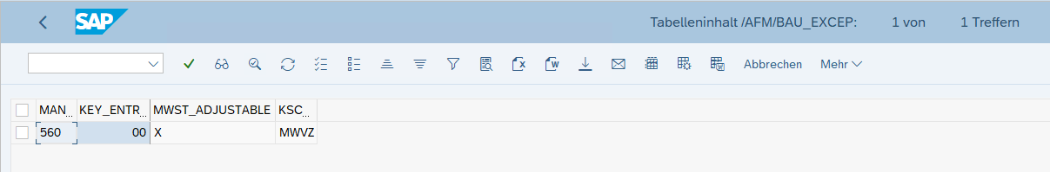  
View🡪/AFM/BAU_EXCEPV

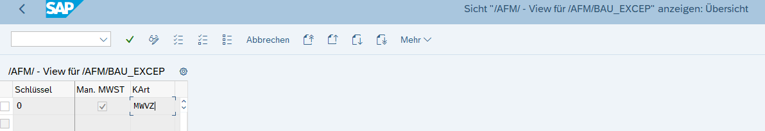

Tabelle🡪/AFM/BAU_STAMMD

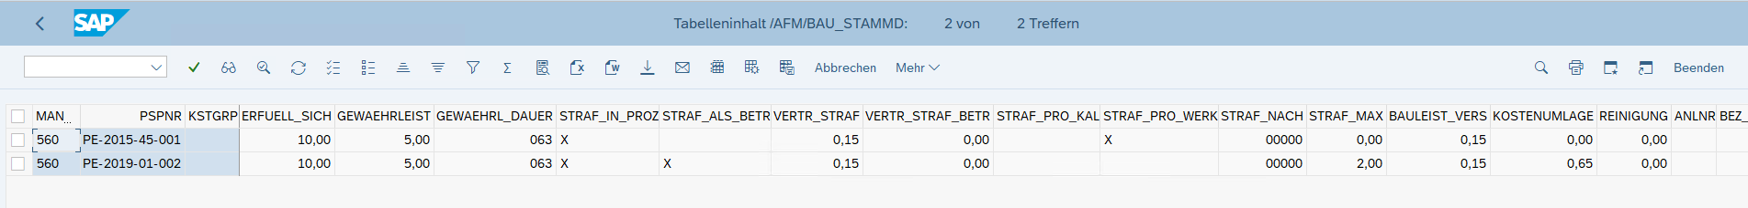

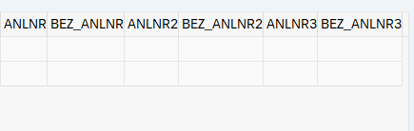

View🡪/AFM/BAU_STAMMDV

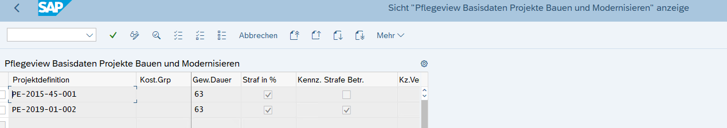

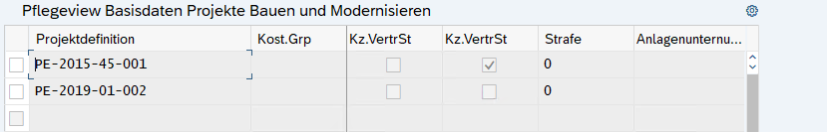

Tabelle🡪/AFM/FI_CUST

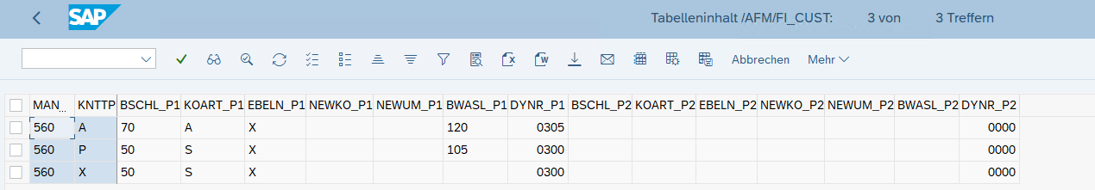

View🡪 /AFM/FI_CUST_V

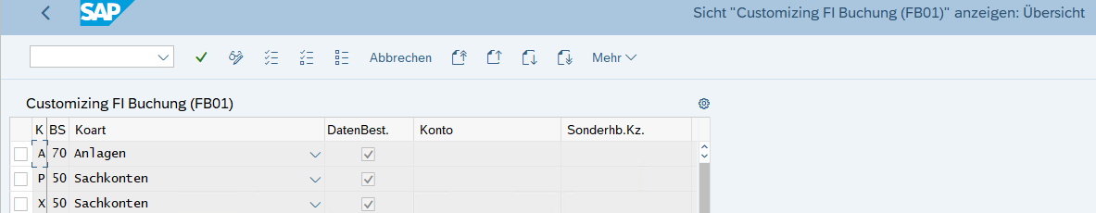

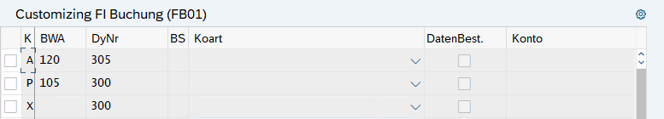

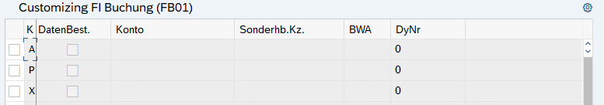

Tabelle🡪/AFM/OAER

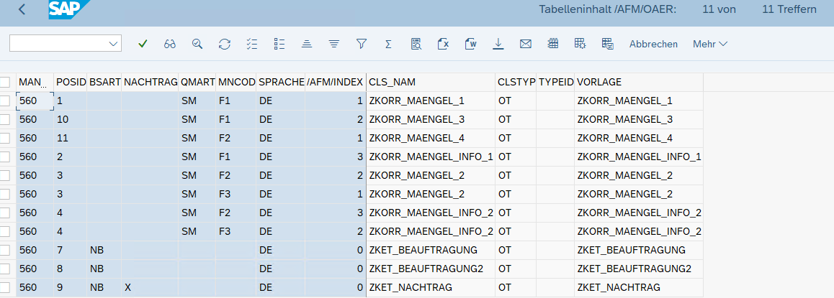

|  |  |  |  |  |  |  |  |  |  |  |  |
| --- | --- | --- | --- | --- | --- | --- | --- | --- | --- | --- | --- |
| 560 | 1 |  |  | SM | F1 | DE | 1 | ZKORR_MAENGEL_1 | OT |  | ZKORR_MAENGEL_1 |
| 560 | 10 |  |  | SM | F1 | DE | 2 | ZKORR_MAENGEL_3 | OT |  | ZKORR_MAENGEL_3 |
| 560 | 11 |  |  | SM | F2 | DE | 1 | ZKORR_MAENGEL_4 | OT |  | ZKORR_MAENGEL_4 |
| 560 | 2 |  |  | SM | F1 | DE | 3 | ZKORR_MAENGEL_INFO_1 | OT |  | ZKORR_MAENGEL_INFO_1 |
| 560 | 3 |  |  | SM | F2 | DE | 2 | ZKORR_MAENGEL_2 | OT |  | ZKORR_MAENGEL_2 |
| 560 | 3 |  |  | SM | F3 | DE | 1 | ZKORR_MAENGEL_2 | OT |  | ZKORR_MAENGEL_2 |
| 560 | 4 |  |  | SM | F2 | DE | 3 | ZKORR_MAENGEL_INFO_2 | OT |  | ZKORR_MAENGEL_INFO_2 |
| 560 | 4 |  |  | SM | F3 | DE | 2 | ZKORR_MAENGEL_INFO_2 | OT |  | ZKORR_MAENGEL_INFO_2 |
| 560 | 7 | NB |  |  |  | DE | 0 | ZKET_BEAUFTRAGUNG | OT |  | ZKET_BEAUFTRAGUNG |
| 560 | 8 | NB |  |  |  | DE | 0 | ZKET_BEAUFTRAGUNG2 | OT |  | ZKET_BEAUFTRAGUNG2 |
| 560 | 9 | NB | X |  |  | DE | 0 | ZKET_NACHTRAG | OT |  | ZKET_NACHTRAG |

View🡪/AFM/OAERV

